Definitions Of Litter Grades

GRADE A – no litter or refuse
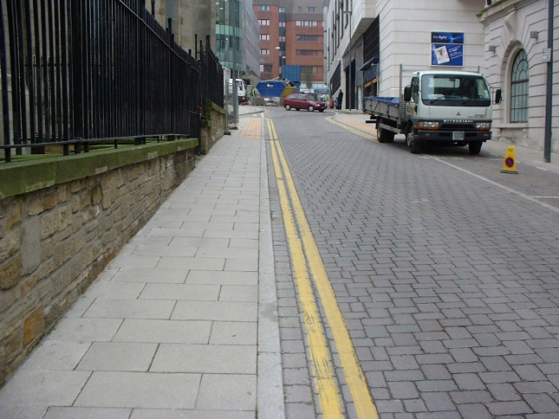

GRADE B – predominantly free of litter and refuse except for some small items
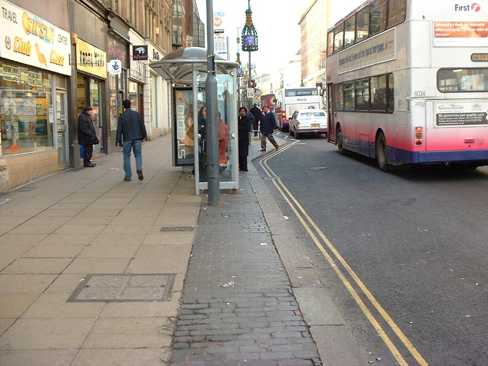

GRADE C – widespread distribution of litter and refuse, with minor accumulations

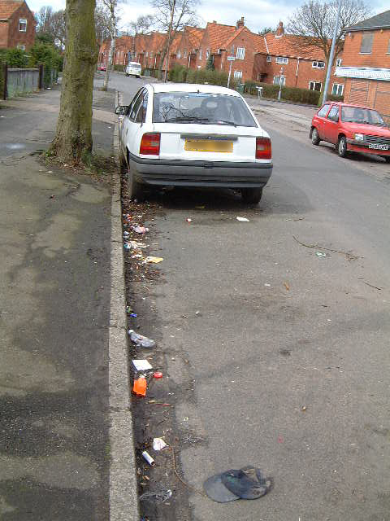

GRADE D – heavily littered, with significant accumulations. Three Intermediate Grades will also be used. These are:

• B +, between Grade A and Grade B

• B – , between Grade B and Grade C

• C –, between Grade C and Grade D
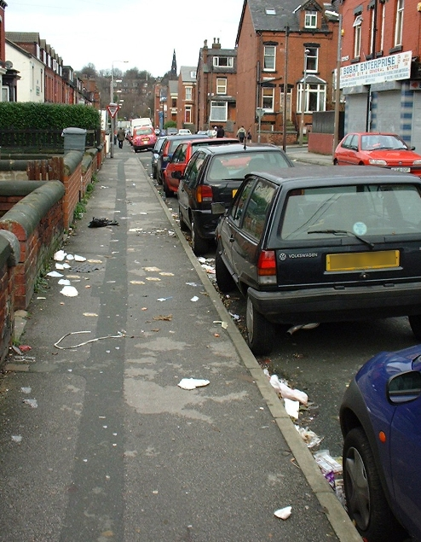
Definitions of Detritus Grades

GRADE A – no detritus present on the transect
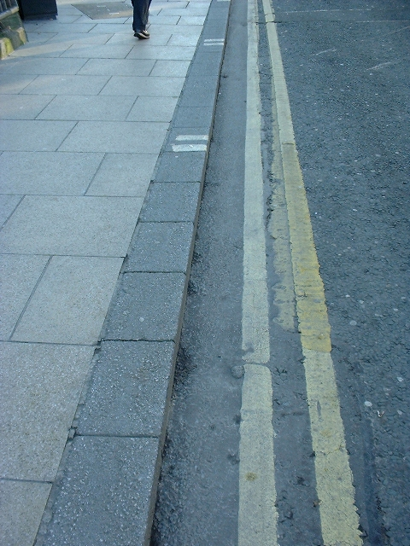

GRADE B – predominantly free of detritus except for some light scattering
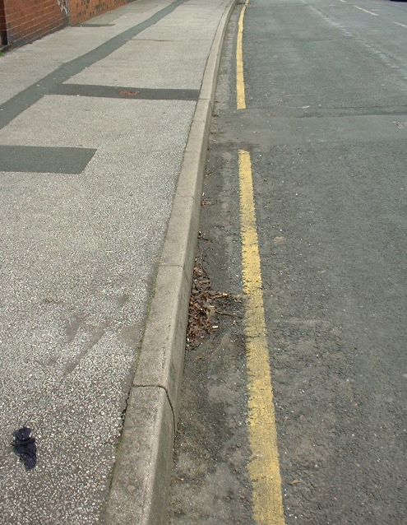

GRADE C – widespread distribution of detritus, with minor accumulations
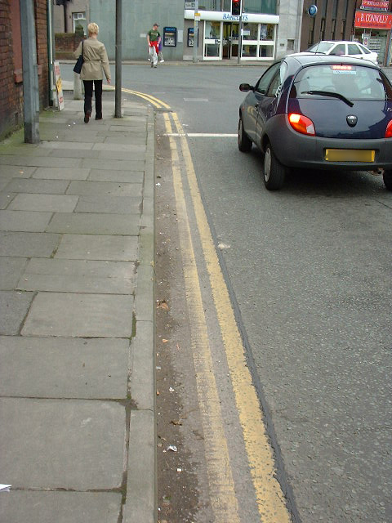

GRADE D – extensively covered with detritus with significant accumulations


